**THIRD TERM E-LEARNING NOTE**

**SUBJECT: AGRICULTURAL SCIENCE CLASS: SS1**

**SCHEME OF WORK**

**WEEK TOPIC**

1 Simple farm tools

2 Farm power

3 Farm mechanization

4 – 5 Anatomy and physiology of farm animals

6 – 7 Reproduction in farm animals

8 Environmental physiology

9 – 10 Livestock management (pig and cattle)

11 Revision

12 Examination

**REFERENCES**

* Essential Agricultural Science for Senior Secondary Schools by O. A. Iwena
* Agricultural Science WAEC PQ
* Practical approach to animal production and health by Akinlade J. A. et al.
* General outlook to livestock production by Akinlade J. A. et al.
* Essential biology for Senior Secondary Schools by M. C. Michael
* Wikipedia

**WEEK ONE**

**SIMPLE FARM TOOLS**

**CONTENT**

* Examples of farm tools
* Description of simple farm tools
* Functions of tools
* Maintenance of simple farm tools

Farm tools are simple handy tools constructed by the farmer or local crafts men to carry out some basic farming operations. Farmers who grow crops and keep animals usually use some simple tools to help make their work easier and faster.

**EXAMPLES OF FARM TOOLS**

|  |  |  |  |  |  |  |  |  |  |
| --- | --- | --- | --- | --- | --- | --- | --- | --- | --- |
| 1. | Cutlass | 2. | Hoe | 3. | Bolt and nut | 4. | Shovel | 5. | Garden fork |
| 6. | Hand fork | 7. | Axe | 8. | Screw driver | 9. | Digger | 10. | Head pan |
| 11. | Spanner | 12. | Mallet | 13. | Budding knife | 14. | Plier | 15. | Harvesting knife |
| 16. | Crowbar | 17. | Sickle | 18. | Wheel barrow | 19. | Shear | 20. | Emasculator |
| 21. | Mattock | 22. | Hammer | 23. | Watering can | 24. | Chisel | 25. | Pruning saw |
| 26. | Secateurs | 27. | Rake | 28. | Hand trowel | 29. | Spade | 30. | Manure drag |

***PRACTICAL/PROJECT: GET A DRAWING BOOK TO DRAW ALL 30 OF THE HIGHLIGHTED FARM TOOLS, WRITE A SHORT NOTE TO DESCRIBE THEM, STATE WAY(S) OF MAINTAINING THEM AND STATE THEIR USE(S).***

**DESCRIPTION AND FUNCTIONS OF SOME SELECTED TOOLS**

1. Cutlass: This is a short metal blade tool some with curve end and a wooden or handle made of rubber. The cutlass is commonly used for land clearing, planting, weeding, and for cutting small trunks and pegs.
2. Spade & Shovel: this has a long wooden handle ending with flat metal blade that is sharp at one end and the other D-shaped to allow for proper handling. It is used for digging the soil, spreading manure, turning and mixing the soil. Shovel blade is folded to give a scoop shape.
3. Garden Fork: this tool has four prongs or teeth made of hard metal that tapers to a point. The hard metal is about 20cm long, mounted on a long wooden handle of about 70-80cm in length. It is used mainly for digging, loosening, breaking the soil.
4. Secateurs: is a scissors like shaped tool consisting of two short metal blades one with a concave curve and the other with a convex curve joined at a pivot with bolt and nut. It possesses two metal short wooden or metal handles with a spring in between. Mainly used for preparing stem cutting and pruning small branches of hard wooded plants for watering crops especially seedlings and flowers.
5. Emasculator: this consists of a pair of powerful pincers with plastic or metal handles. It is use to castrate male animals by rushing their spermatid cord

**GENERAL MAINTENANCE OF FARM TOOLS**

Farm tools are made of metal or wood which are strong, these tools still need very good care so that they are always suitable for use in farming. The following are ways to ensure that they are used optimally:

1. Keep in a store free of termites (for tools with wooden parts).
2. Oil or grease metal parts
3. If it is to be stored for long, paint metal parts
4. Sharpen blunt edges regularly to get optimum result.
5. Clean or wash after each use.
6. Keep nozzles free from blockage.

**EVALUATION**

1. List seven types of farm tools used for post planting activities.
2. How can we maintain simple farm tools?

**READING ASSIGNMENT**

Essential Agricultural Science for Senior Secondary Schools by O.A. Iwena pages 88 – 101.

**WEEKEND ASSIGNMENT**

1. Which of these farm tools is used for weeding?A. Cutlass B. Watering can C. Rake
2. Which of these farm tools is used for digging, loosening andbreaking the soil?

A. Secateurs B. Hand towel C. Garden fork

1. Which of these farm tools is used for transplanting of seedling? A. Go-to-hell B. Shears C. Hand Towel
2. Which of these farm tools is used for harvesting rice? A. Shears B. Sickle C. Ranging pole
3. Rubbing farm tools with oil prevent ____. A.rustingB. raking C. wear and tear D. decay

**THEORY**

1. Describe four tools used in carrying out pre planting operations.
2. Which farm tool is used for pruning and preparing stem cutting?

**WEEK TWO**

**FARM POWER**

**CONTENT**

* Definition of farm power
* Sources of farm power
* Advantages and disadvantages of farm power

**DEFINITION OF FARM POWER**

Power is the rate of doing work or the expenditure of energy. Power is measured in units of joule/seconds otherwise known as watts. Farm power is the ability provided by various sources to carry on farm work. Farm power then can be defined as the energy, force and source used to carry out farming operations.

**SOURCES OF FARM POWER**

**HUMAN POWER**

This is the most important source of farm power without which all other sources are useless. It involves the use of man’s intellect and/manual effort to carry out different farming activities. The great advantage of human power is man’s intelligence which means he is able to control the work he does.

 ADVANTAGES OF HUMAN POWER

1. Man’s intelligence to control the work he does.
2. Man has the advantage to control all other sources of power
3. It is required in all farm operations
4. It is easily controlled and available.

DISADVANTAGES OF HUMAN POWER

* 1. The output per man per hour is very low.
  2. Total production can only be of subsistent level.
  3. A lot of drudgery is associated with the use of human power.
  4. Man is exposed to high or low temperature, humidity, wind, pollution etc. when used as a source of power on the farm.

**EVALUATION**

1. What is farm power?
2. Mention two advantages and two disadvantages of human power

**ANIMAL POWER OR ANIMAL TRACTION**

This is the use of animals in carrying out various operations on the farm. Pair of working bullyolked together, camels, donkeys etc, are common animals normally used. Man controls the animals where they are utilized. The power supplied by animals is for pulling plough, harrow, planter, ridger etc. and for transporting the farm product.

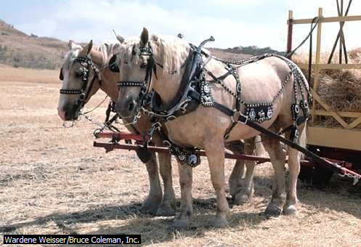

Belgian Heavy Draft Horses

Belgian heavy draft horses have great strength. Farmers in Belgium sometimes use these horses for plowing instead of tractors, which can get stuck in wet soil.

ADVANTAGE OF WORK ANIMALS

1. The use of animal power makes much less demand of human power as it is often proves more effective in farming activities.
2. Animals can work for a long time if properly fed.
3. It has a relatively low maintenance when compared to machines.
4. It can handle many farm operations.
5. It can be controlled.

DISADVANTAGES OF WORK ANIMALS

1. They can refuse to work if not properly handled
2. The cost of maintaining the animals feeding, veterinary servicesetc is high
3. Diseases may affect the efficiency of work animals
4. There is a limitation in the output of animals particularly in hot climate
5. They cannot work in Tse-tse fly infested areas.

**MECHANICAL POWER**

This requires the use of series of machines to carry out farm operations. Power transmitted through engines can come directly or indirectly from electricity or from the burning of fuel.

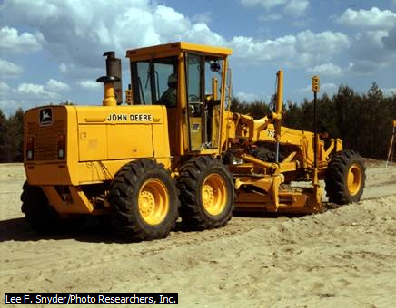

ADVANTAGES OF MECHANICAL POWER

1. It can do more work per unit time more than man and animals.
2. Unlike human and animal power there is no fear of diseases.
3. It can be used in tsetse fly infected area.
4. They are the fastest and most efficient source of farm power.
5. They make farm operations timely

DISADVANTAGESOF MECHANICAL POWER

1. High capital investment is involved in the accusation of machineries.
2. Many tractors are laid off in West Africa due to lack of spare parts.
3. It is not suitable for small land holdings.
4. Intensive mechanization displaces labour from the farm and can lead to unemployment.
5. It is not readily available.

**EVALUATION**

* 1. What are the advantages of mechanical power over work animals
  2. State two disadvantages each of A. work animals B. mechanical power

**ELECTRICAL POWER**

This is power derived from electricity or generator. It is a neat or clean source of energy. It is used to operate electric motors. Motors are used to operate many modern appliances such as heater, incubator, mixer and some power tools. Electrical power is also measured in watts.

ADVANTAGES OF ELECTRICAL POWER

* + 1. It is easy to operate
    2. It is efficient and it saves labor
    3. It is a cheap source of farm power
    4. It gives quick and immediate result.
    5. It can be used for various services and at different time.

DISADVANTAGESOF ELECTRICAL POWER

* + - 1. Electricity supply is not regular especially in developing countries like Nigeria.
      2. Electrical fault may cause serious hazards.
      3. It cannot be widely used in the field.
      4. Cost of installation and maintenance is high.
      5. It is dangerous and fatal if carelessly handled

**SOLAR POWER**

This is the power derived from radiation, light and heat reaching the earth from the sun. This energy is the ultimate source of energy and it can be converted into electrical energy by installing solar panels. Solar energy is trapped into photo – voltaic cell or solar collectors which is then converted into electrical energy and stored in batteries or used directly.

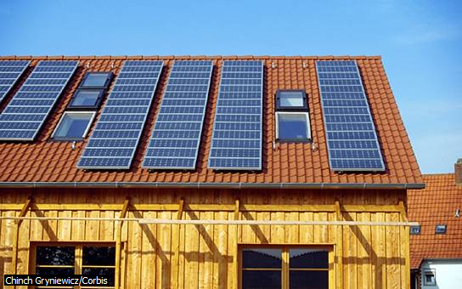

Solar Power

These solar panels convert energy from sunlight and can be used to generate electricity.

ADVANTAGES OF SOLAR POWER

1. Solar power is inexhaustible.
2. Solar energy can be used to dry crops, power machines and generate electricity.
3. Solar energy technology is environment friendly.
4. It is readily available.
5. Solar panels have long life span.

DISADVANTAGES OF SOLAR POWER

1. It requires a lot of technical knowhow.
2. It is only available during the day.
3. Its provision cannot be controlled.
4. It cannot be adjusted on readily stored.
5. Excess of it can cause transpiration and evaporation.

**EVALUATION**

* 1. Outline four uses each of A. solar power B. electrical power
  2. What are the disadvantages of electrical power

**WIND POWER**

This is the power generated by wind movement. Wind power is made possible through the use of windmill that helps to pump water out of the boreholes or in generating electricity.

A water-pumping windmill in spring, Arizona, provides water for agricultural use. The blades, or sails, are mounted at an oblique angle on the horizontal shaft. The fantail rudder steers the bladed wheel into the wind to maximize the windmill’s efficiency.

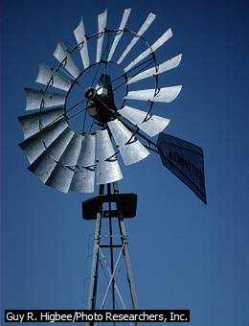

ADVANTAGES OF WIND POWER

1. Wind can be harnessed to drive boats, power grinders and to operate water pumps.
2. It can be used for drying farm produce.
3. It is cheap and available everywhere.
4. It is used in winnowing, i.e. separation of chaff from grains.
5. It can serve as alternative to electrical power.

DISADVANTAGES OF WIND POWER

1. The supply of wind is sporadic and uncertain.
2. A large windmill often proves to be very expensive for the energy it produces.
3. It cannot be stored.
4. It is difficult to control.
5. It is limited to certain farm operations.

**WATER POWER**

This is the power derived from water flowing in rivers, oceans, dams etc. It is used in hydro-electric stations to drive the turbines. A turbine is a rotating engine with its blade driven by water.

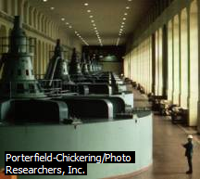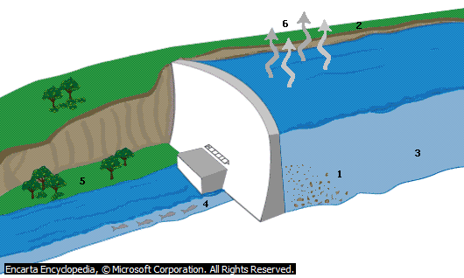

**Electricity Generators**

Generators at the Bonneville Dam in Oregon produce electricity as water flows through large turbines and drives the axles of the generators. The Bonneville Dam is located on the Columbia River between the states of Oregon and Washington. The Bonneville plant is one of many hydroelectric stations in the northwestern United States.

ADVANTAGES OF WATER POWER

1. A steady and uninterrupted flow of water can be made to turn turbines or water wheels to generate electrical energy.
2. It is used in transportation of farm goods.
3. It can be used to process farm produce.
4. It is needed in seeds germination and normal growth of crops
5. It is needed in the process of photosynthesis by plants.

DISADVANTAGES OF WATER POWER

1. Low level of water can hinder electricity output.
2. It is not available in all areas.
3. It could be destructive if not carefully handled.
4. Supply is affected by weather.
5. It cost huge sum of money to set up and maintain

**EVALUATION**

* 1. State four uses each of A. water power B. wind power
  2. Mention two disadvantages of wind power

**BIOGAS**

A method of generating power by making use of farm wastes, especially animal dung, urine etc collected and processed to produce methane gas.

ADVANTAGES OF BIOGAS

* 1. A cheap source of power.
  2. It can be used to generate heat for brooding chicks.
  3. It can be used for cooking and drying.
  4. It can also be harnessed to generate electrical energy.
  5. It can easily be controlled.

DISADVANTAGES OF BIOGAS

* + 1. It requires expertise which may not be easily available.
    2. It is expensive to set up and maintain.
    3. It is not a common source of power.
    4. It is restricted to where animals are reared on a commercial basis.
    5. If not properly handled, it can lead to fire incidence.

**GENERAL EVALUATION**

1. What is farm power?
2. What are the sources of farm power?
3. State three advantages and disadvantages each of

a. Wind power b. Water power c. Solar power d. Electrical power e. Animal power

f. Biogas

1. State three uses of biogas
2. List three sources of hydroelectric power

**READING ASSIGNMENT**

* Essential Agricultural Science Chapter for Senior Secondary Schools by O.A. Iwena pages 14, page 122 - 129.
* Answer the following questions from WAEC PAQ 2005 theory question 1, 2008 theory question 1

**WEEKEND ASSIGNMENT**

1. The most common source of farm power drying grains in West Africa is A. heat engine

B.sun C.waterD.electricity

1. ____ can be harnessed to generate electricity. A. PetrolB. Animal dung C. Biogas

D. Turbines

1. The most unreliable source of farm power is A. Wind B. Water C. Electricity D. Machines
2. Water power is harnessed and converted into electrical power by A. blade B. grains

C. turbines D. hovercraft

1. The fastest and most efficient source of farm power is ____ power.A. Solar B. Animal

C. Mechanical D. Biogas

**THEORY**

1. List two farm operations each requiring the use of A. Machine B.Electricity C.Wind

D.Solar radiation

1. In what way is human power the most important source of farm power?

**WEEK THREE**

**FARM MECHANIZATION (TRACTORIZATION)**

**CONTENT**

* Definition
* Advantages of mechanization
* Disadvantages of mechanization
* Problems of mechanization
* Prospects of mechanization

Mechanization refers to the application of engineering principles and technology in agricultural production. It is the use of machines such as tractors, ploughs, harvesters, harrow, planter etc as well as the use of farm inputs such as insecticides, improved seeds, fertilizer etc.

The objective of mechanization is to:

* reduce human labour (that is to reduce drudgery)
* increase efficiency
* save cost (on the long run)
* save time
* improve standard of living by improving quality and quantity of produce available.

**ADVANTAGES OF FARM MECHANIZATION**

1. It ensures that farm operations are done and completed within a shortest possible time
2. It saves labour that could otherwise be useful elsewhere.
3. It reduces health hazards and accidents that can occur from using tools.
4. It reduces drudgery.
5. It encourages large scale farming hence increasing output.
6. It promotes specialization of labour for example machines operators become specialists in the machines they handle.
7. It increases cooperation among farmers such as enabling them put their resources together to buy machines and use them on rotational basis thereby making them united.
8. It on the long run saveslabour cost, wastage, reduces errors and spoilage thereby leading to an increase in income (saved cost).

**DISADVANTAGES OF FARM MECHANIZATION**

1. It involves huge capital investment.
2. With mechanization very few workers are needed which renders other laborers unemployed.
3. The movement of heavy duty machines on land leads to compaction of the soil.
4. The smoke from exhaust of machines can cause air pollution.
5. Due to small land holdings as a result of the system of land tenure, use of machinery is not encouraged (e.g communal land tenure).
6. Continuous usage of machines on the soil tends to destroy the soil structure.
7. Very few crops like maize, rice etc can be mechanized.

**EVALUATION**

* 1. State five advantages of farm mechanization.
  2. State five disadvantages of farm mechanization.

**LIMITATION OF FARM MECHANIZATION**

1. Inadequate spare parts.
2. Farmers are generally poor, cannot afford to buy machines like tractors etc.
3. There is inadequate technical know-how on how to operate and repair farm machines.
4. As a result of small area of land cultivation, it is not economically advisable for farmers to use machines on their farm. This problem is created by land tenure system.
5. Seasonality of farm operation: Machines may be left unused because of seasonality nature of farming.
6. Uneven land terrain makes it difficult to operate farm machines.
7. Inadequate storage and processing facilities discourages large scale production.

**EVALUATION**

* 1. Define mechanization
  2. Outline five problems of farm mechanization in Nigeria

**PROSPECTS OF MECHANIZATION**

* 1. Farmers should be educated to accept modern system of mechanization.
  2. Provision of loans to enable farmers to purchase farm machines.
  3. Farmers should pool their resources together to buy farm machines.
  4. Land tenure system should be reviewed to make land available for farming.
  5. Simple and less expensive machines should be developed for farmer to acquire.
  6. There should be engineering personnel trained to work on machines.

**EVALUATION**

* + 1. Outline five factors limiting farm mechanization in Nigeria.
    2. What are the possible ways of improving agriculture through mechanization.

**GENERAL EVALUATION**

* + 1. What is mechanization?
    2. Outline five problems of agricultural mechanization.
    3. State five advantages and disadvantages of farm mechanization.
    4. State five limitations of farm mechanization.
    5. State five possible ways of improving agriculture through mechanization.

**READING ASSIGNMENT**

* Essential Agricultural Science for Senior Secondary Schools by O.A. Iwena pages Chapter 13, page 117 – 121.
* Answer the following questions from WAEC PAQ 2005 theory question 2, 1992 theory question 2

**WEEKEND ASSIGNMENT**

1. Which of the following is an advantage of farm mechanization? A. Carrying out many farm operations with ease B. Displacing many farm workers C. Exposing soil to direct effect of sunlight D. polluting the environment
2. In which of the following operationscan a tractorbe effectively used for? A.Fertilization B.Harvesting C.PloughingD.Stumping
3. Mechanization in West Africa is limited by the following except?A. Size of farm holdings B. Technical Knowhow C. Capital D. Labor
4. Which of the following gives the correct order of usage of tillage implements in a virgin land A. Harrow Plough RidgerB. Harrow RidgerPloughC.Ridger Plough Harrow

D. Plough Harrow Ridger

1. Which crop is best cultivated by mechanical means?A.Cassava B.Cocoa C.Maize D.Oil palm

**THEORY**

* + 1. What is mechanization?
    2. State four advantages and disadvantages each of mechanization in agriculture.

**WEEK FOUR**

**ANATOMY AND PHYSIOLOGY OF FARM ANIMALS**

**CONTENT**

* Digestive system
* Circulatory system
* Reproduction system

**DIGESTIVE SYSTEM**

* Digestive system and digestion
* Digestion in ruminant (polygastric) animals
* Digestion in non-ruminant (monogastric) animals
* Digestion in poultry birds
* Differences between monogastric and polygastric animals.

DIGESTIVE SYSTEM AND DIGESTION

The digestive system of farm animals includes all the organs and tissues associated with the breaking down or digestion of food in the body. It includes the teeth or beak, tongue, the alimentary canal or digestive tract and all the associated gland secreting enzymes and other body fluids.

Digestion is the breakdown of foods substances in the digestive tract into absorbable forms. This process starts from the mouth through mastication which increases the surface area and allows microbes to have quicker access to act the food substances.

Farm animals are grouped into two main classes based on the nature of the alimentary canal or digestive tract. There are polygastric (ruminant) animals and monogastric (non – ruminant) animals.

DIGESTION IN RUMINANT ANIMALS

These are farm animals which possess complex stomach made up of four compartments or chambers. These are rumen (paunch) which is the first, reticulum or fore stomach (honey comb), omasum(the fardel, manyplies or psalterium) and abomasum (true stomach). These animals can ruminate or chew the cud. Exampleof farm animals having this stomach compartment includes cattle, sheep, goat etc.

Cattle for example when feeding gather some quantity of grasses with its tongues and grip it firmly between the upper jaw and the teeth of the lower jaw; it jerks its head and swallows the grasses. The grasses pass through oesophagus and enter the rumen, where digestion of cellulose by bacteria takes place.

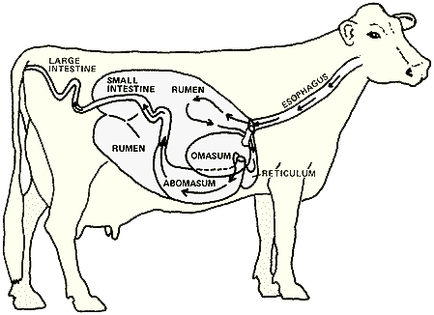

When the cattle has filled its rumen, it lies down quietly and by anti–peristaltic movement of the stomach the undigested grass or cud passes from the rumen to the reticulum from where it goes back to the oesophagus and back to the mouth to be masticated (this process is referred to as regurgitation). It then chews the food properly into a semi-liquid cud (bolus) with the premolars and molars which re-swallowed. The cud moves into the omasum and passes into the last chamber, abomasum where gastric juice containing digestive enzymes are secreted into the semi–digested food to form the chyme. The chyme goes into the small intestine through the duodenum where further digestion and absorption of nutrients takes place. The undigested material then passes out through the anus as dung.

**EVALUATION**

* + - 1. What are ruminant animals? Give five examples.
      2. Describe briefly digestion in cattle.

DIGESTION IN NON-RUMINANT ANIMALS

These animals possess only one stomach structure and they do not ruminate (that is they do not chew the cud). The animals cannot digest cellulose and fibers properly. Examples include pigs, poultry etc. Pig has a simple stomach. It feeds mainly on basal feeds like maize, cassava and other meshed food. Digestion of foods takes place in four area of the tract.

1. Mouth: In the mouth, the food is changed and mixed with saliva which contains an enzyme Ptyalin. Ptyalin converts starch to maltose. The food (bolus) is then swallowed and moved by peristaltic movement to the stomach.
2. Stomach: here, two enzymes, pepsin and rennin are present. Renin act on milk and pepsin convert protein to peptones. The thick liquid formed(chyme) now passes to the duodenum.
3. Small intestine

Duodenum:Here, the pancreas secretes pancreatic juice which contains three digestive enzymes i. e.

1. Amylase – Converts starch to maltose
2. Lipase – Converts fats and oil to fatty acid and glycerol
3. Trypsinogen – Converts protein and peptones to polypeptides

The digestion of fats and oil is aided by bile. Bile helps in the emulsification of fats. At the duodenum, the food now in liquid form called chyle passes to the ileum of the small intestine. In the Ileum,secretion of enzymes which furthers the process of digestion takes place. These enzymes are

1. Lipase – convert fats and oil to fatty acid and glycerol
2. Erepsin – Converts polypeptides to amino acid
3. Maltase – Converts maltose to glucose
4. Lactase – converts lactose to glucose and galactose
5. Sucrase – converts sucrose to glucose and fructose

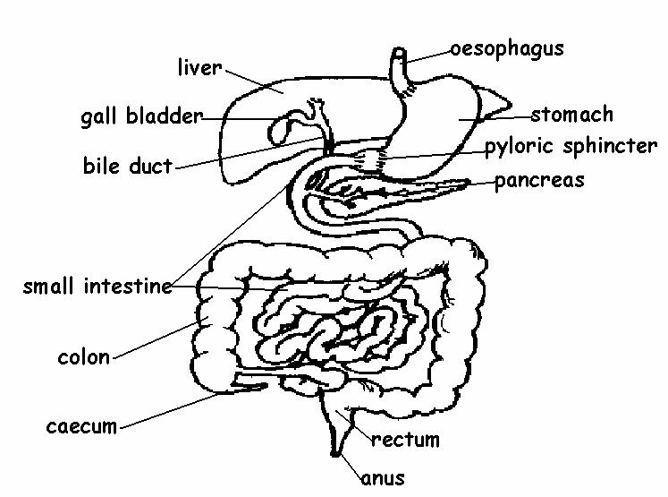

The end product in the digestion of protein is amino acid, starch is glucose and fats and oil is fatty acid and glycerol.

**EVALUATION**

* + - 1. What are non-ruminant animals?
      2. List the digestive enzymes in A. stomach B. small intestine C. pancreas D. liver and their functions.

DIGESTION IN POULTRY BIRDS

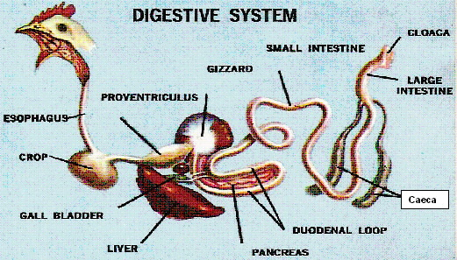

The domestic fowl is a monogastric animal that possesses a simple stomach. The fowl has no teeth but the food is picked up by the beak. The food then passes on to the crop through oesophagus. The food is stored temporarily in the crop, there moistened and fermented by some bacteria. The food now passes on to the proventriculus (glandular stomach) where digestive juice such as pepsin and amylase are secreted on the food.

From the proventriculus, the food moves to the gizzard where grinding of the food takes place. From the gizzard, the food moves to the small intestine where further digestion and absorption takes place. The undigested food materials are removed from the digestive tract as faeces.

**DIFFERENCES BETWEEN MONOGASTRIC AND POLYGASTRIC ANIMALS**

|  |  |  |
| --- | --- | --- |
| S/N | MONOGASTRIC | POLYGASTRIC |
|  | It cannot ruminate or chew cud | It can ruminate or chew cud |
|  | Feed is mainly basal and concentrated food | Feed is mainly grasses and other cellulose |
|  | Possess one stomach compartment | Possess four stomach compartment |
|  | It cannot digest cellulose and fiber properly | It can digest cellulose and fiber very well |
|  | Digestion is not aided by bacteria | Digestion is aided by bacteria |
|  | It cannot synthesis their own protein | It can synthesis their own protein |

**EVALUATION**

* 1. Describe briefly digestion in domestic fowl.
  2. Differentiate between ruminant and non-ruminant animals.

**READING ASSIGNMENT**

* Essential Agricultural Science for Senior Secondary Schools by O.A. Iwena pages chapter

29, page 266 - 269

* Essential Biology for Senior Secondary Schools by M. C. Michael page 215 – 216

**CIRCULATORY SYSTEM**

Circulatory system consists of all the tissues and organs that are involved in the transportation of materials through the blood round the body offarm animals. Farm animals possess closed circulatory system. This means that oxygenated and deoxygenated blood does not mix. They also display a pattern of double circulation(this mean that for one complete circulation to occur, the blood must pass through the heart twice; first to the lungs for oxygenation and then on return to the other parts of the body) or single circulation as in the case of fish.Circulatory system has three (3) main divisions. These are:

1. The Blood
2. The Blood vessels, and
3. The Heart

THE BLOOD: Mammalian blood is made up of plasma andblood Cells, which are;

1. Plasma-liquid part of the blood. It contains water, blood proteins (e.g fibrinogen),dissolved mineral salt, waste product, digested food.
2. The Blood Cells(corpuscles)
3. Red blood cells (Erythrocytes): biconcave, circular in shape and no nucleus when matured, contain iron pigment called haemoglobin that helps to transport oxygen, produced in bone marrow,
4. White blood cells (Leucocytes): irregular in shape, few than red blood cells, have nucleus, produced in lymphatic tissues. They defend the body against foreign bodies.
5. Blood platelets (Thrombocytes): irregular or star-shaped, tiny, non-nucleated, produced for blood clotting.

FUNCTIONS OF THE BLOOD

1. Maintain body temperature through uniform distribution.
2. Carries oxygen through the red blood cells.
3. Transports hormones from ductless gland
4. Transport metabolic waste to where they are removed.
5. Defend body against germs via leucocytes
6. Platelets help in blood clotting
7. Transports digested food to cell.
8. Maintain water level and turgidity of the body

THE BLOOD VESSELS: these are a network ofspaces in the body through which material are movedfrom one part of the body to the other with the aid of blood. There are three major blood vessel, they are:

* 1. Artery: carries blood away from the heart to other part of the body. It further divides into arterioles.
  2. Vein: this vessel caries blood back to the heart from other parts of the body. It further divides to form veinous.
  3. Capillaries: tiny bloods vessel around tissues and organs where arteries and veins

meets.

THE HEART: This is a muscular organ responsible for pumping blood round the body. Each pump action of the heart isknown a heartbeat. The heartis located in the thoracic cavity of the body, protected by the pericardium. It consists offour chambers:the upper: auricle (right and left), the lower: ventricles (right and left). A central wall divides the right and left part of the heart called septum. The auricles and ventricles are divided on the right by a tricuspid valve and on the left by a mitral/bicuspids valves.

**EVALUATION**

1. What is circulatory system?
2. List the functions of blood.

**READING ASSIGNMENT**

* Essential Agricultural Science for Senior Secondary Schools by O.A. Iwena chapter 29, page 269 – 272
* Essential Biology for Senior Secondary Schools by M. C. Micheal page 230 - 237

**REPRODUCTIVE SYSTEM OF FARM ANIMALS**

Reproduction is the biological process that gives rise to new organisms (offspring) from their parent. This includes all the organs and tissues concerned with reproduction in animal. Reproduction is the ability of animals to give birth to young ones. The purpose of reproduction is to ensure continuity of life. Farm animals reproduce sexually and mostly viviparous (given birth to life form of their young). Poultry birds and fishes are oviparous (they both lay eggs and poultry brood over theirs while fishes do not). Fertilization in most farm animals is internalbut external in fishes and hormones play an important role in the processes of reproduction as well as in the development of sex-inhibited characters.

MALE REPRODUCTIVE SYSTEM

The male reproductive system include the testes which produces the spermatozoa and sex hormone called testosterone which aid the development of male secondary sexual characters. The spermatozoa are produce in the testes or testicles by a process called Spermatogenesis. The testes may be suspended (as in cattle, sheep and goat) and is protected by scrotal sac (scrotum) outside the abdominal cavity to enable the sperm cells to be produced at desired temperature. The epididymis ensures the storage maturation of sperm cells in the testes, i.e. store sperms until they are matured. The testes are connected to the uterus masculinus by vas deferens which transports sperms from testes to the uterus masculinus where mature spermatozoa are stored until they are released during mating.

Attached to the side of the urethra are accessory glands i.e. Cowper’s gland also called bulbourethral gland, seminar vesicles and prostate gland which produces slimy alkaline fluid which aids the movement of spermatozoa. The fluid together with spermatozoa results in the formation of semen, the urethra is an uro-genital organ which helps to inject sperms into the vaginal as well as the removal of urine. The urethra ends externally in penis.

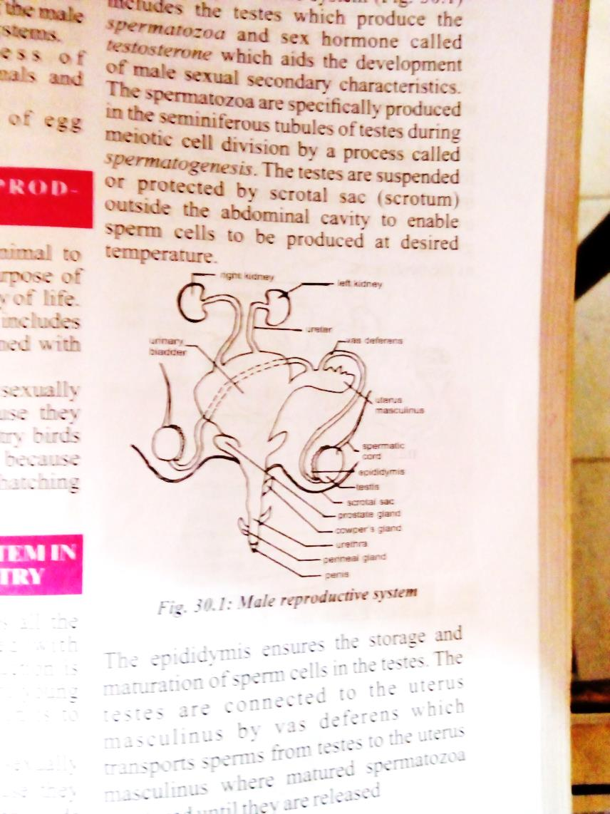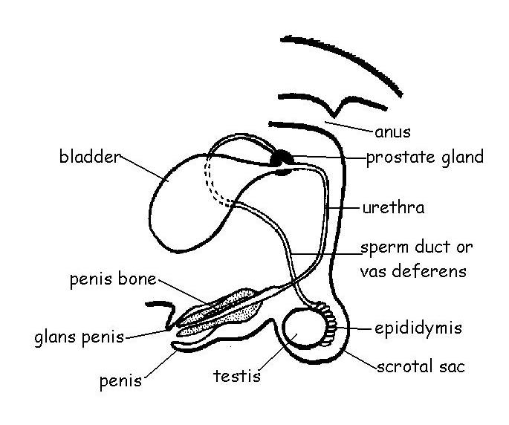

Male reproductive system of farm animals

FEMALE REPRODUCTIVE SYSTEM

The female reproductive system consist of a pair of ovaries that produces egg cells or ova and fallopian tubes where fertilization occurs an which transports the fertilized ovum to the uterus. The uterus is the place in the female reproductive system where the growth of foetus takes place. The cervix separates the uterus from the vagina or birth canal. The entire system ends with the vulva (labia majora and minora) to the external.

Vagina is a fibro muscular tube of 7.5 to 10cm in length, situated anterior to the rectum and anal canal and posterior to the bladder and urethra. It is the organ of copulation, deposition of semen, and exit from uterus during parturition. The accessory organ of the female reproductive system includes outermost portion of the vagina (vestibule). The cowper’s glands also called bartholin’s gland is 1.5 to 2.0cm in length located above the perineal gland. It secretes mucus to provide vaginal lubrication.

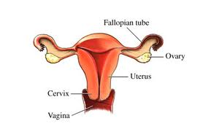

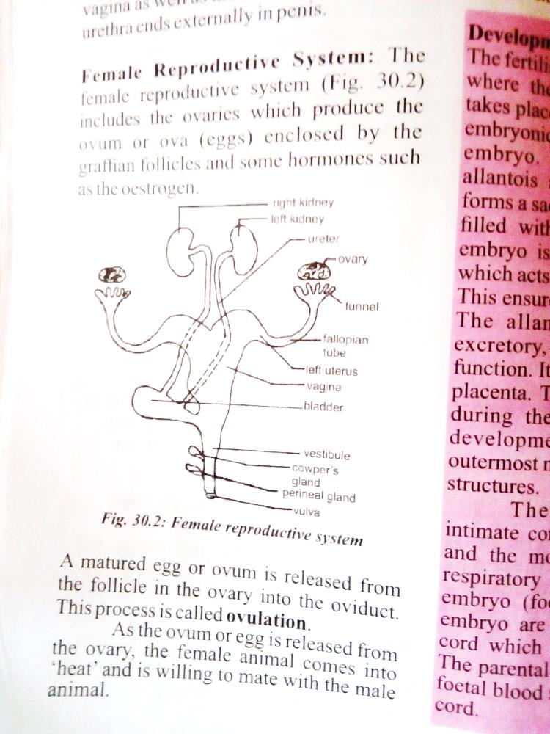

The female reproductive system

**EVALUATION**

1. What is reproduction in farm animals?
2. Name the accessory glands located along the urethra in male animals.

**GENERAL EVALUATION**

1. Describe the female reproductive system.
2. What are the similarities of monogastric and polygastric animals in the area of digestion?
3. What are the main components of circulatory system?

**READING ASSIGNMENT**

* Essential Agricultural Science for Senior Secondary Schools by O.A. Iwena chapter 29, page 281 – 283
* Essential Biology for Senior Secondary Schools by M. C. Micheal pages 337 - 345

**WEEKEND ASSIGNMENT**

1. Stomach of ruminant animals is made up of the following except A. gizzard B. reticulum C. abomasum D.manyplies
2. Digestion of food start in farm animal from A. mouth B. caecum C. small intestine

D. stomach

1. Which of these is not part of the male reproductive organ A. testes B. oviduct

C. epididymis D. vas deferens

1. The part of the female reproductive system responsible or lubricating the vaginal is known a ____ A. mucus B.perineal gland C.cowper’s gland D. epididymis
2. ____ is a major constituent of blood A.HaemoglobinB. WaterC. CalciumD. Serum

**THEORY**

1. Describe digestion in a named polygastric animal.
2. Differentiate between monogastic and polygastic animals.
3. What are sphincters?

**WEEK FIVE**

**RESPIRATORY SYSTEM**

**CONTENT**

* Respiratory system
* Nervous system

**RESPIRATORY SYSTEM**

Respiratory system includes all the organs and tissues associated with the exchange of gases between the animal and its environment, leading to the release of energy. The purpose of respiration is to supply oxygen to the cell which burns down food to release energy.

**C6H12O6 + 6O2 🡪 6CO2 + 6H2O + ENERGY**

**(Glucose) (Oxygen) (Carbon dioxide) (Water) (ATP)**

TYPES OF RESPIRATION

1. Aerobic respiration: This is the type of respiration that takes place in the presence of

oxygen.

**C6 H12 O6 + 6O2 🡪 6CO2 + 6H2O + ENERGY**

**(Glucose) (Oxygen) (Carbon dioxide) (Water) (ATP)**

1. Anaerobic respiration – This is the type of respiration that takes place in the absence of oxygen. Anaerobic respiration is also known as fermentation.

**C6H12O6 🡪 2C2H5OH + 2CO2 + ENERGY**

**(Glucose) (Alcohol) (Carbon dioxide) (ATP)**

RESPIRATORY ORGANS

This refers to organ such as the lungs in land animals and gills in aquatic animals.

Land animals use lungs for respiration. Other organs that aid respiration in land animals are the nostrils (two external openings of the nasal cavity in vertebrates that admit air to the lungs), pharnyx,Larynx (situated just below where the tract of the pharynx splits into the trachea and the oesophagus). The trachea (windpipe) is a cartilaginous tube that connects the pharynx and larynx to the lungs, allowing the passage of air, and so is present in almost all air-breathing animals with lungs. The trachea extends from the larynx and branches into the two primary bronchi. Epiglottis disallows entrance of food particles into the trachea. bronchi is a passage of airway in the respiratory system that conducts air into the lungs.The bronchioles or bronchioli are the passageways by which air passes through the nose or mouth to the alveoli (air sacs) of the lung. Alveoli are tiny sacs within the lungs that allow oxygen and carbon dioxide to move between the lungs and bloodstream.

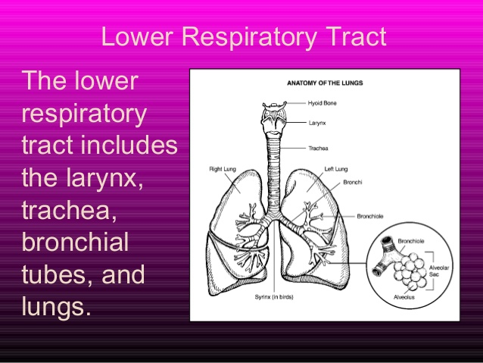

The lungs

PROCESS OF BREATHING

Breathing process is an activity that takes place consciously or not, process of breathing moves air in and out of the lungs. Inward movement of air is called inhalation while exhalation is the outward movement of air from the animal body.

Aquatic animals use gillswhich are located on both side of the head region for respiration. Thegills are in threes or fours arranged in the gill chamber. Each gill consist of a gill filament where gaseous exchange takes place, gill raker that prevent particlesfrom entering the gill chamber, gill arch on which the gill filament are built. The gill chamber is closed externally by operculum.

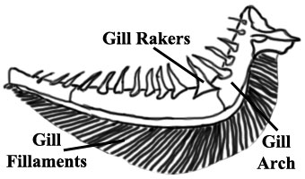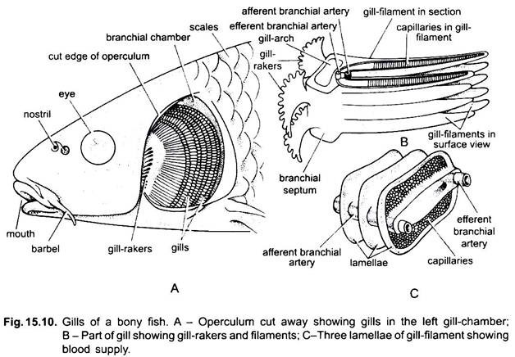

Diagram of fish gill

**EVALUATION**

1. Describe the process of inhalation and exhalation.
2. Differentiate between the two types of respiration.

IMPORTANCE OF THE RESPIRATORY SYSTEM

1. Supplies oxygen to the body cells
2. It reduces heat load in the body especially in poultry.
3. Removes carbon dioxide from the body
4. Promotes gaseous exchange

**EVALUATION**

1. Define Respiration.
2. List and explain the two types of respiration.
3. How does fish respire in water?
4. Represent Aerobic Respiration in chemical equation
5. Describe the process of respiration in a named animal?

**READING ASSIGNMENT**

* Essential Agricultural Science for Senior Secondary Schools by O.A. Iwena chapter 29 page 272 – 274
* Essential Biology for Senior Secondary Schools by M. C. Micheal page 248 - 258

**NERVOUS SYSTEM**

The nervous system includes all the organs and tissues which enable farm animals to respond to changes in their environment. The change in the environment is called stimulus and the reaction of the living things to the stimulus is response. The nervous system is made up of two parts;

Central Nervous System: This includes the brain and the spinal cord. Both are made up of thousands of nerves and neurons. The functions of C.N.S. are correlation of impulses from various sense organs and storage of impulses as information.

Peripheral Nervous System: This consists of cranial and spinal nerves. The P.N.S. mediates between animals and its external environment.

**GENERAL EVALUATION**

1. Write brief notes on a) Respiratory system b) Nervous system
2. Distinguish between the central nervous system and peripheral nervous system.

**READING ASSIGNMENT**

* Essential Agricultural Science for Senior Secondary Schools by O.A. Iwena chapter 29 page 274 – 276
* Essential Biology for Senior Secondary Schools by M. C. Micheal page 313 – 324
* Answer the following questions from WAEC PAQ 1994 theory question 8

**WEEKEND ASSIGNMENT**

1. The lungs is to rabbit while____ is to fishes A. trachea B. Gill C.bronchiD.oesophagus
2. The wind pipe in the respiratory system of land animals is the A. Larynx B. Pharynx

C. alveoli D. trachea

1. Which of the following performs the same function in the gills as epiglottis A. Chamber B. Filament C. Operculum D.Raker
2. The changes in environment that triggers response in animals is called A. Action

B. Response C. Stimuli D. impulse

1. The structural and functional unit of the nervous system is the ____ A. spinal cord

B. brain C. neurons D. spinal fluid

**THEORY**

Describe briefly a simple reflex action in animals and state four examples

**WEEK SIX**

**REPRODUCTION IN FARM ANIMALS**

Reproduction is the process that gives rise to young in farm animals; it is the ability of animals to birth young. This process starts when the animal is sexually matured. Time of sexual maturity varies between animals, in cattle it takes up to 15 months, in goat and sheep about 6 months, poultry about 18 weeks etc. The following terms are associated with reproduction in farm animals.

**OESTRUS CYCLE**

This is the interval from the end of one heat period to the beginning of another. It is under the influence of hormone called oestrogen.It is the sexual cycle that occurs in all female animals if the animal is not pregnant. The period varies among farm animals:

Cow – 20 – 21 days

Ewe – 17 – 21 days

Sow – 14 – 28 days

Doe (goat) – 17 – 21 days

Doe (rabbit) - spontaneous

**OVULATION**

This is rupturing of ovarian wall to release egg into the fallopian tube in farm animals; a process is controlled by luteinizing hormone (LH) and follicle stimulating hormone (FSH). It varies among

farm animals

Cow => 10 – 14 hours

Ewe => 20 – 24 hours

Sow => 24 – 36 hours

Doe (goat) => 12 – 36 hours

Doe (rabbit) => spontaneous

**HEAT PERIOD**

This is the period in which female animals have the urge to copulate or accept the male animal. The female show signs of readiness to mate. It is controlled by oestrogen. It varies among farm animals

Cow => 5 – 24 hours

Ewe => 35 – 36 hours

Sow => 40 – 48 hours

Doe (goat) => 40 – 50 hours

Doe (rabbit) =>spontaneous

SIGNS OF HEAT IN FARM ANIMALS

1. Restlessness
2. Mucus secretion by the cervix
3. Swollen and reddened vulva
4. Loss of appetite and frequent urination
5. Viscous secretion comes from the vagina and these arouse and excite the males
6. Abnormal body temperature
7. Grunting
8. Frequent urination
9. Standing still to be mounted on

**In summary, ovulation (release of eggs) then heat period (receptivity to mating) then oestrus period (preparatory period for next ovulation)/pregnancy if there is successful mating that leads to fertilization.**

**EVALUATION**

1. Differentiate between oestrus cycle and heat period.
2. List the duration of ovulation in cow, pig, goat and rabbit.

**MATING**

This is also called coitus or copulation (sexual intercourse). This is the act in which the penis of the male animal is inserted into the vaginal of the female animal leading to introduction of sperm into the vagina. Mating could be natural or artificial.

NATURAL MATING

It occurs when a male after identifying a female on heat, mates with the female animal. Examples of natural mating include:

1. FLOCK MATING

This is a deliberate act in which the male and female animal are allowed to move together

ADVANTAGES FLOCK MATING

1. All animals have freedom to participate in sexual intercourse
2. The farmer is saved the labor and cost of monitoring breeding
3. All female may be mated because the number of males are widely spread

DISADVANTAGES FLOCK MATING

1. A female may be mated by more than one male thereby paternity become a difficult thing to determine
2. Two female may be on heat at the same time, thereby leading to the mating of only one of them.
3. PEN MATING

This form of mating occurs in pigs and poultry. A male is given a specific number of female depending on the strength of the breed. About 1 male to 20 females on heat

ADVANTAGES PEN MATING

1. In poultry female eggs can be produced
2. There is tendency of servicing female on heat

DISADVANTAGES PEN MATING

1. The spread of venereal diseases may be rampant
2. Deformed male may not be able to mate
3. STUD MATING

A male (stud)with proven qualities is kept in a room in this type. Any female that is on heat is led to it for mating and thereafter the female is removed.

ADVANTAGES STUD MATING

1. The paternity of the offspring can be identified
2. It is a good system of upgrading the breed because only male with both proven quality is used.

DISADVANTAGES STUD MATING

1. The spread of venereal diseases may be rampant.
2. It takes a lot of expertise to practice.

ARTIFICIAL MATING

This is called artificial insemination, which involves the act of inserting the spermatozoa artificially into the vagina of female animals on heat. The sperm is collected from a male animal with desired characters with the aid of an artificial vagina, massage method, etc. Sperm collected is stored in liquid nitrogen at -196°C.

ADVANTAGES ARTIFICIAL MATING

1. The semen can be used over a long time even after the death of the male animal.
2. It is more economical as it reduces the cost of feeding and managing male animals.

DISADVANTAGES ARTIFICIAL MATING

1. It requires expertise which may not be readily available.
2. Difficulty in detecting female animals on heat may limit success.

**EVALUATION**

1. Explain briefly the term artificial mating.
2. Mention two advantages and two disadvantages of artificial mating
3. State two ways of collecting semen from male animals.
4. Differentiate between ovulation, heat period and oestrus cycle
5. List five sign of heat in animals.

**FERTILIZATION**

This is the fusion of the male and female sex cells spermatozoa and ovum respectively. This process occurs in the Fallopian tube or oviduct.

**IMPLANTATION**

This is the attachment of zygote (fertilized egg) to the wall of the uterus after fertilization. The zygote develops into a foetus and continues to grow till time of parturition.

**GESTATION PERIOD**

This is a period between fertilization of an ovum to the birth of young ones, conception and

birth. During gestation, female animals do not come on heat. It is under the control of hormone called progesterone (Pregnancy hormone).

FEATURES OF GESTATION PERIOD

1. There is swelling of abdomen
2. There is swelling of adder
3. There is increase in body weight

|  |  |  |
| --- | --- | --- |
| SPECIES | NAME OF FEMALE | GESTATION PERIOD |
| Horse  Cattle | Mare  Cow | 336 days  283 days |
| Goat | Doe | 150 days |
| Sheep | Ewe | 150 days |
| Pig | Sow | 114 days |
| Rabbit  Chicken | Doe  Hen | 31days  21 days |

**PARTURITION**

This is the act of giving birth in farm animals. It marks the end of pregnancy and the beginning of lactation. The act of parturition for each animal is unique.

Cow – Calving

Sow – Farrowing

Ewe – Lambing

Goat (Doe) – Kidding

Rabbit (Doe) – Kindling

Poultry – hatching

SIGNS OF APPROACHING PARTURITION

1. Mammary glands enlarge and begin to secrete milk substance
2. Vulva swells and become soft
3. There may be thick mucus discharge
4. The animal become restless lies down and get up frequently
5. The animal urinate frequently
6. Loss of appetite
7. The animal tries to build a nest and beds e.g. in rabbit

**EVALUATION**

1. Write short note on: i) Gestation ii) Parturition
2. State five signs of parturition in farm animals.
3. What name is given to parturition ina) Sheepb) Cattlec) Pig

**LACTATION**

This is the period during which the female releases milk from its udder immediately after parturition and thereafter. Lactation is under the control of hormone called oxytocin, it can be increased by injecting animal with oxytocin.

Lactation is also be stimulated by the presence of the young ones, presence of a milker, the use of hand to rub the udder and the use of machine to milk the cow. The milk from goat is the best and richest of all the animals. Milk collected from animals is made fit for consumption via a process known as pasteurization.

**COLOSTRUM**

This is the milk produced immediately after parturition within the first five days of milk production is essentially colostrum. It is yellowish-white milk. It is important for the new born animals to take colostrum because

1. It contain some anti-biotic against diseases to which the mother has been exposed.
2. It enables the new born to get immunity against diseases
3. It is rich in protein especially albumin and globulins
4. It is rich in vitamins.
5. It is highly digestible and has a laxative effect which helps the young ones to expel the feaces.

**READING ASSIGNMENT**

* Essential Agricultural Science for Senior Secondary Schools by O. A. Iwena pages 281 – 288.
* Essential Biology for Senior Secondary Schools by M. C. Micheal pages 337– 344.
* Answer the following questions from WAEC PAQ 2007 theory question 7, 2016 theory question 4 and 5c, 1991 theory question 7, 1994 theory question 7 and 2015 theory question 4b

**GENERAL EVALUATION**

* + 1. What is reproduction in farm animals?
    2. What is implantation?
    3. Lists five signs of approaching parturition
    4. Why is colostrum important for the new born animals?

**WEEKEND ASSIGNMENT**

1. The interval from the end of a heat period to the beginning of another is ____

A. ovulation B.anaestrusC.oestrus cycle D. implantation

1. The following are influence by oestrogen hormone except A. lactation B. ovulation

C.oestrusD. heat

1. Natural mating predisposes animals to ____ diseases A. cholera B. venereal C. malaria

D.dounch

1. A male animal with desirable characters kept mainly for mating is called a ____

A.dounchB. stud C. bull C. heifer

1. The gestation period of a pig is A. 150 days B. 114 days C. 32 days D. 280 days

**THEORY**

1. Write short note on the development of an embryo.
2. Describe the right positioning of a lamb prior to expulsion.

**WEEK SEVEN**

**REPRODUCTION IN FARM ANIMALS II**

**CONTENT**

* Processes of egg formation in poultry
* Male and female reproductive hormones

**PROCESSES OF EGG FORMATION IN POULTRY**

The egg in poultry is partly formed in the ovary and in the oviduct. At ovulation the ovum carrying the yolk is released by the **ovary** into the **oviduct** through the funnel called infundibulum. Fertilization takes place in the **infundibulum** where the egg spends 15 minutes and moves into the magnum. In the **magnum**, part of the egg white (albumen) and the chalaza are secreted round the yolk. The egg stays for 3 hours in the magnum and moves into the **isthmus** where the two shell membranes are formed. The egg stays for 1 hour 15 minutes in the isthmus and moves into the **uterus** where it remains for 18 – 21 hours and the egg shell is formed from calcium carbonate. Mineral solutions are also added to the egg before it moves into the **vagina** whereit remains for 1 – 15 minutes before it is laid through the **cloaca**. A complete formation of eggs takes almost 26 hours.

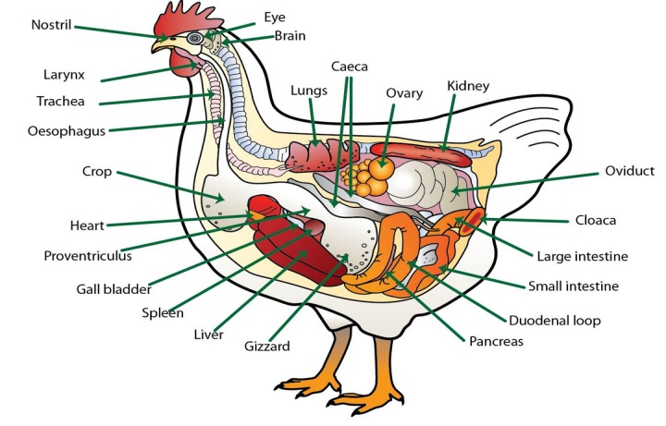

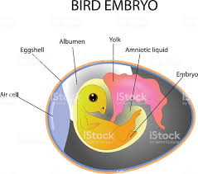

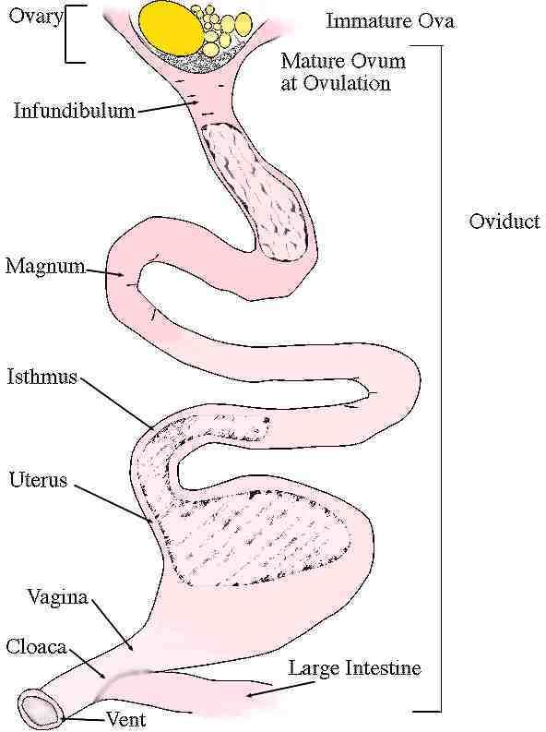

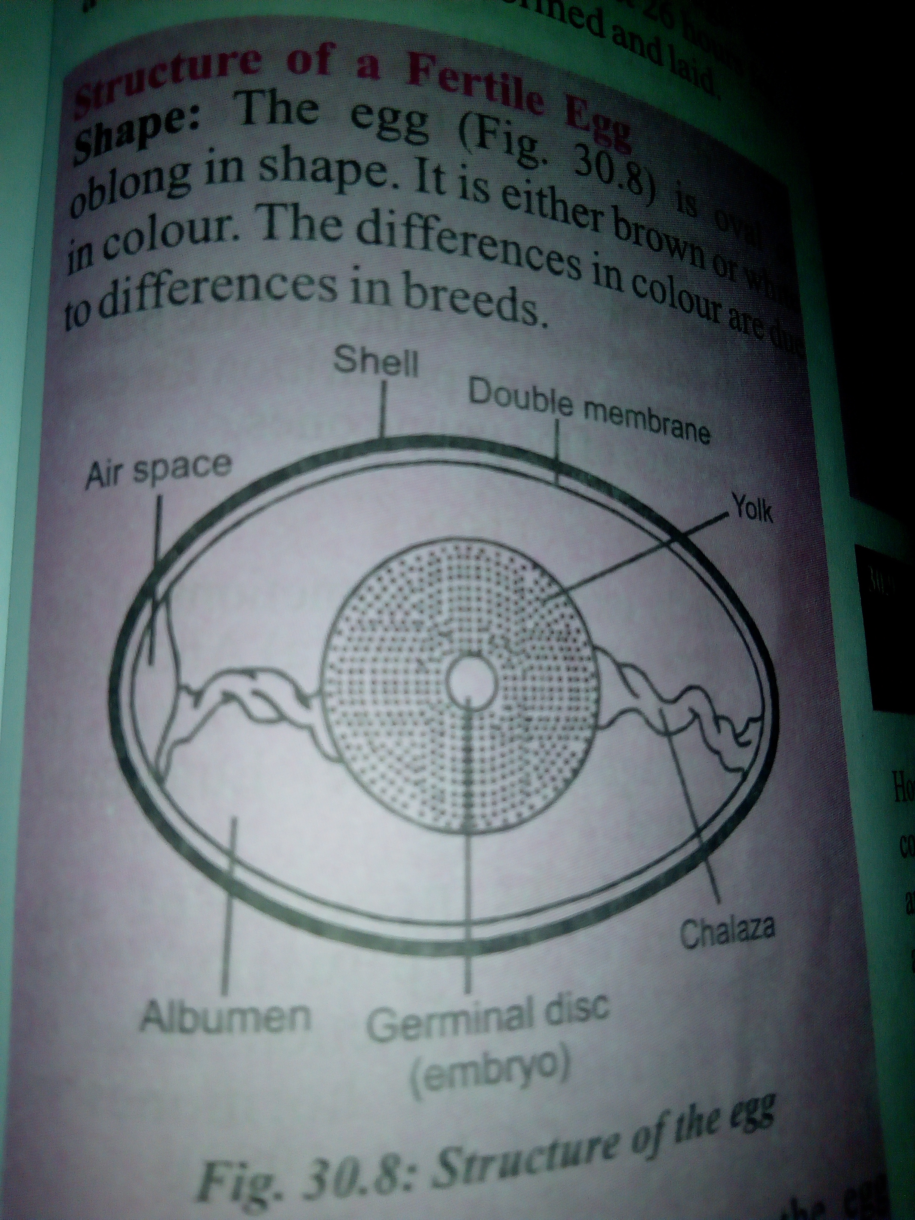

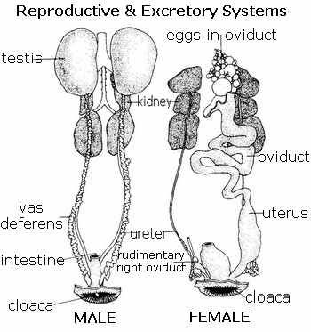

REPRODUCTIVE SYSTEM OF POULTRY BIRDS

**EVALUATION**

1. Describe the processes of egg formation in poultry.
2. Describe the reproductive system of poultry birds.

**MALE AND FEMALE REPRODUCTIVE HORMONES**

Hormones are organic chemical substances produced by endocrine (ductless) glands which

influence growth, development and metabolic activities in farm animals. These include

|  |  |  |  |
| --- | --- | --- | --- |
| HORMONE | SEX | SITE OF SECRETION | FUNCTIONS |
| Testosterone/ Androgen | Male | Testes | It stimulates the development of secondary sexual characters in male.  It stimulates sperm production through spermatogenesis. |
| Oestrogen | Female | Ovary | It stimulates the development of secondary sexual characteristics in female animals  It promotes the production of ova or eggs through oogenesis.  It stimulates mammary gland development |
| Progesterone | Female | Corpus luteum | It ensures uterus development and implantation of the fertilized ovum.  It inhibits oestrus i. e. prevents ovulation.  It stimulates the development of mammary gland  It ensures the continuance of pregnancy. |
| Oxytocin | Female | Pituitary | It aids the contraction of the uterine wall during parturition.  It promotes milk let-down after parturition.  It aids sperm transportation in the vagina. |
| Relaxin | Female | Pituitary | It aids relaxation of pelvic ligaments during parturition. |
| Follicle stimulating hormone (FSH) | Female | Pituitary | It stimulates the growth of ovarian follicle. |
| Luteinizing hormone | Female | Pituitary | It stimulates the secretion of oestrogen and progesterone.  It causes the rupture of the follicle and the release of the ova from the follicle. |

**GENERAL EVALUATION**

1. List five animal hormones and function.
2. What are the functions of the following in the processes of egg formation in poultry?
3. Ovary
4. Oviduct
5. Magnum
6. uterus

**READING ASSIGNMENT**

* Essential Agricultural Science for Senior Secondary Schools by O.A. Iwena chapter 30 page 288 – 290.
* Answer the following questions from WAEC PAQ 2015 theory question 4a

**WEEKEND ASSIGNMENT**

1. Which of these is not a part of the male reproductive system A. uterus masculinusB. oviduct C. testes D. vas deferens
2. The following except one are female reproductive hormones A.oestrogenB. progesterone C. testosterone D. oxytocin
3. Fertilization in poultry birds takes place in the A. infundibulum B. isthmus C.magnumD. uterus
4. The following except one are viviparous animals A. pig B. cattle C. turkey D. goat
5. The hormone responsible for the contraction of the uterine wall during parturition is known as A. oxytocin B. progesterone C. luteinizing hormone D.relaxin

**THEORY**

1. Draw and label the diagram of an egg.
2. List five reproductive hormones, site of secretion and their functions.

**WEEK EIGHT**

**ENVIRONMENTAL PHYSIOLOGY**

**CONTENT**

* Definition
* Effect of changes in climate on growth, milk production and egg production

Environmental physiology refers to the effects of the environment on the growth and performance of farm animals. It is the study of the environment in relation to the response of farm animals. The effects could be high or low in nature. Moderation is the target for optimum growth and performance.

CLIMATE

Climate refers to the atmospheric condition of a place over a period of time. It is marked by rainfall, wind, temperature, humidity, sunlight etc.

RAINFALL

1. High rainfall increases pests like tsetse flies, and diseases
2. High rainfall causes chilling of young ones
3. High rainfall does favor rearing of dairy animals
4. Extremes of rainfall do not favor growth of grasses for foods

CONTROL OF RAINFALL

1. Shelter
2. Rain break
3. Drainage channels
4. Building orientation

WIND

1. Wind aids the spread of air-borne diseases e.g. tuberculosis; and death eventually
2. Moderate wind velocity promotes good ventilation.
3. Scare animals producing undesirable level of growth hormones.

CONTROL OF WIND

1. Shelter
2. Wind break
3. Openings
4. Building orientation

TEMPERATURE

1. High temperature causes a reduction in food intake; low temperature encourages more feed intake
2. High temperature reduce spermatogenesis and libido in males
3. High temperature causes heat stress and reduced activity.
4. It may result in death of animals; in adult animals e.g birds, young animal e.g chicks and production animals e.g layers
5. It increase water intake in hot weather and reduces water intake in cold weather.
6. It is necessary for incubation of eggs
7. It lowers yield e.g. lower egg production
8. It affects product storage period under high climatic condition
9. High temperature affects the young ones e.g. hatching of egg is reduced.

CONTROL OF HEAT AND TEMPERATURE

1. Introduce fans or air conditioners to animal house.
2. Provide enough windows or opening for ventilation
3. Cover windows with cloth materials to conserve heat
4. Provide vents at the roof tops;
5. Use poor conductors of heat for roofing/ sun reflecting sheets or paint roof with reflecting color e.g. white. Pens should also have ceiling boards under the roof
6. Use room heaters or lanterns to warm building when it is cold

RELATIVE HUMIDITY

1. It is very important in physiological processes e.g. incubation.
2. High humidity compounds stress.
3. Low humidity induces rapid water loss from animal body and thus increases their water intake
4. High humidity encourages the spread of diseases
5. High humidity causes feeds to go moldy
6. Causes chilling of young ones

CONTROL OF HUMIDITY

1. Fixing humidifiers or open trays filled with water to increase humidity
2. Allowing free ventilation when the humidity is high
3. Avoidance of spilling of water to reduce humidity or dampness e.g. in poultry house

LIGHT

1. Controls egg laying in hens
2. Duration of lightning controls time spent at feeding which regulates growth and the rate of feathering, furring.
3. Direct light of high intensity causes stress to the eyes
4. Bright light makes the animals active e.g. birds
5. Light makes objects visible to animals’ eyes

CONTROL OF LIGHT

1. In short daylight, provide extra illumination
2. There should be openings to promote lighting e.g. use of wire meshing and glass as reasonable parts of building construction.
3. Cover up windows with dark cloth to reduce light intensity.

EFFECT OF CHANGES IN CLIMATE ON GROWTH

The effect of climate on growth could be economically positive or negative to the farmer in that if they are extreme (excessively hot or cold) animals will not eat well and thus not grow well or each more and still not grow well. Other instances includes

1. Wind aids spread of disease
2. High rainfall causes more incidence and multiplication of Tsetse fly and other pest
3. High humidity favors mould growth in pens and also in feed which could cause diseases

A favorable climate cteris paribus should give room for farmers to make optimum gain from their enterprise. To this end, farmers ought to keep things in check such as

* 1. Installing fans and air conditioners
  2. Plan for good ventilation when constructing animal house
  3. Used building materials that are poor conductors of heat
  4. Painting walls of animal house white to reflect sun rays
  5. Construct farm houses east west direction
  6. Use mesh in place of brick wall at some heights
  7. Install humidifiers or open trays filled with water to increase or reduce humidity.

And try to control all they can to ensure their investment do not go to waste.

EFFECT OF CHANGES IN CLIMATE ON MILK PRODUCTION

Excess sunlight brings about heat stress, high humidity favors growth of pathogens, milk will spoil at a temperature higher than 37°C. All these causes reduction in milk yield

EFFECT OF CHANGES IN CLIMATE ON EGG PRODUCTION

High temperature reduces shelf life for eggs, hatchability, feed intake, and decrease in quantity of egg produced. Light length increases feeding time for birds which may not translate into extra yield.

**EVALUATION**

1. What is environmental physiology?
2. Write short notes on the effect of changes in rainfall and wind on growth in farm animals.
3. State two air-borne diseases that affect farm animals.

**GENERAL EVALUATION**

1. Write short notes on the effect of changes in the following on physiological processes in farm animals a) Temperature b)Relative Humidity c) Light
2. State the ways to control rainfall and wind.

**READING ASSIGNMENT**

* Environmental Physiology from Essential Agriculture by O.A. Iwena pages 292-294
* Answer the following questions from WAEC PAQ 2007 theory question 8 and 2000 theory question 7

**WEEKEND ASSIGNMENT**

1. The instrument used to measure the relative humidity is A.thermometer

B.anemometer C.hygrometer D.hydrometer

1. Which of the climate factors is likely to have the greatest effect on animal production in Nigeria? A. temperature B.air movement C. rainfall D.pressure
2. The factors that can predispose animals to diseases include the following except A. poor housing B. malnutrition C. immunity D. physical injuries
3. The effects of high environmental temperature on dairy cows include the following except A. fever B.high feed intake C.high water intake D.low milk production
4. The equatorial rain forest belt is not usually used for cattle production because of the A. low relative humidity B.absence of natural grasslands C.incidence of Tsetse flies

D.dense vegetation

**THEORY**

1. Discuss brieflyA.rainfall B.light C.temperature in relation to poultry production.
2. Write short note on the effect of temperature on brooding of chicks.

**WEEK NINE**

**LIVESTOCK MANAGEMENT**

**CONTENT**

MANAGEMENT OF A MONOGASTRIC ANIMAL (PIGS)

* Terms used in pigs management
* Breeds of pigs
* Characteristics of pigs
* System of rearing pigs
* Housing, feeding and hygiene
* Management of pigs

Pigs are non-ruminant animals in the genus sus, within even-toed ungulate family suidae. They are primarily reared for meat.

TERMS USED IN PIGS MANAGEMENT

Boar: a mature male pig Sow: a mature female pig

Piglet: young or baby pig farrowed Barrow: a castrated male pig

Pork: pig’s meat In-sow: pregnant sow

Dry sow: a sow that is not pregnant Fatheners: pigs reared for meat

Farrowing: act of parturition in pigs Lard: pig fat

Gilt: mature female pig that has not reproduced or has only reproduced once

BREEDS OF PIGS

Hampshire Yorkshire (Largewhite) Poland china Landrace

Berkshire Large black West African dwarf Duroc

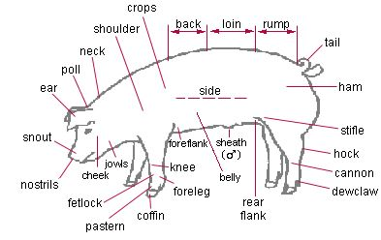

CHARACTERISTICS OF PIGS

1. Pork is a good source of protein
2. It has a short gestation period of 114 days ( 3 months, 3 weeks, 3 days)
3. Pigs are prolific animals, it farrows twice a year with 8-14 piglets per litter.
4. Have excellent dressing percentage (the ratio of meat to bone is very high)
5. Excellently converts feed to meat
6. Matures quickly (6 – 9 months)
7. They are polyestrus (they can breed at any time of the year)
8. Their salvage value is high

**EVALUATION**

1. List five breeds of pigs.
2. List and explain five terms used in pig management.
3. Outline five characteristics of pigs

SYSTEMS OF REARING PIGS

EXTENSIVE SYSTEM

This is a system in which pigs are allowed to move out and fend for themselves. The system is not capital intensive. The animals are exposed to adverse weather condition. They are exposed to disease and parasite infestation. Advantage of this system includes low cost of labour, low capital requirement, reduced feeding cost, spread of disease is reduces etc. Disadvantage of this system includes increased exposure to disease causing agents, increased risk of theft, exposure of animals to adverse weather conditions, no monitoring of animals, production is relatively low.

SEMI-INTENSIVE SYSTEM

In this system, housing is provided for the pigs and they are allowed to move out to feed on

natural vegetation. They are housed in a fenced compound with a wallow place where they can cool their body temperature. The system is less capital intensive but labor requirement, diseases and parasite infestation are slightly high. Concentrate feed are offered to the animals.

INTENSIVE SYSTEM

In this system, pigs are confined within a building and they are not allowed to move out of the compound. They are reared in pens. Necessary materials such as feeds, water, medications are provided for them. They are protected from adverse weather condition but the system is capital intensive and growth rate is very high.

**EVALUATION**

1. Discuss briefly the extensive system of rearing pigs.
2. What are the advantages and disadvantages of the intensive system of rearing pigs?

HOUSING OF PIGS

Pigs are housed in pens. Pens should be sited far from residential areas because of their odor and noises. The house should be made of low walls with concrete floors which allow for free flow of air. The floor should be hard and slope towards the drain for easy cleaning. The floor should be slightly rough to prevent slippery of pigs. The roof should be made of asbestos for easy absorption of heat. Feed trough, water trough and water bath should be provided.

FEEDING

Balanced diet should be offered to pigs. They should be well fed but not over fed to prevent excessive fat deposition. Breeders mash should be fed to breeders. Flushing which is the intake of the gilt or sow to produce more eggs should be done 7-10 days before breeding and maintained until the animal is bred. Pregnant or in-sow should not be over fed so as to prevent excessive deposition leading to small litter size. Laxative diet should be given to pregnant animals to aid easy parturition and lactation. Creep feed should be given to piglets as from two weeks of age to promote rapid growth. Creep feeding is feeding piglet separate from the dam (the feed is either pelleted or crumbled). Weaners diet should be given to weaners from about 14 weeks at the rate of 1kg / pig / day and 2.5litres of water. During fattening stage, fatteners mash should be given to pigs until they reach market weight of 60-90kg at 7months.

HEALTH/HYGIENE

1. The pens should be regularly cleaned by scrubbing the floor.
2. The pens should be regularly disinfected to prevent germs.
3. The feeding and water trough should be cleaned to prevent contamination.
4. They should be de-wormed at regular interval.
5. They should be vaccinated against diseases.

**EVALUATION**

1. What is the importance of the following feed in pig management A. laxative B. creep feed C. fatteners mash?
2. Discuss briefly hygiene in pigs’ management.

MANAGEMENT OF PIGS

The management of pigs from breeding to finishing is discussed under 3 headings.

BREEDING TO FARROWING

Breeders are housed in the breeders’ house. Boar and gilt should be at least 8months old before they are bred. The gilt must have at least 12 spaced functional teats. Gilt or sow is made to mate in the second day of heat and the next mating done 24 hours later.

The gilt should be taken to farrowing house 3 to 4 days before parturition.

BIRTH TO WEANING

Heat is provided for the piglets to prevent cold. The middle tooth is cut off to prevent injury to the mother’s teats and other piglets while fighting.

The first dose of iron dextian injection is given to piglets at 2-3 days of age while the second dose is given 2-3 weeks later to prevent baby pig anaemia.

Male piglets not needed for breeding are castrated at 2 weeks of age. They are ear-notched for the purpose of identification and weaned at 42 days.

WEANING TO FINISHING

Weaner’s are fed with weaner’s mash and fattener’s mash few weeks later. Drugs and vaccines should be provided. They should be allowed to exercise their body to prevent fat build up.

Wallow place should be provided since they are non-sweating animals.

Fatteners reach market weight at about 5-6 months of age depending on management and nutrition.

PARASITES AND DISEASES OF PIGS

The greatest enemy of animal production is parasite and disease, it has no good, all bad is what comes from it. To this end farmers must ensure they put things such as

1. Effective management
2. Adequate nutrition
3. Proper hygiene and sanitation
4. Well-designed housing

in place to save guard their investment.

External parasites include mange, mites, ticks, lice, flea all these can be controlled by spraying their post with pesticide regularly or dipping them in insecticide solution.

Internal parasites are round worm (ascarislumbricoides), whip worm (trichurissuis), nodular worm (oesophagostomum app), kidney worm (stepphanurusdentatus), lungworm (metastrongylus app), tapeworm (taeniasolium). They can be controlled by giving animals broad spectrum anthelmintics and dewormers, timely cleaning of graces from pig houses.

COMMON DISEASE IN PIGS

AFRICAN SWINE FEVER

This is a highly contagious disease caused by virus and likely transmitted by tick. It is characterized by high fever, loss of appetite, depression, weak and uncoordinated movement, reddening of skin around ears, nose, and hind legs, abortion in pregnant sow, respiratory disorder (labored breathing, nasal and ocular discharge), and death within 48 hours.

This disease has no treatment yet but can be avoided by obtaining stock from ASF free farms, slaughter infected pigs and disinfect pig houses thoroughly with 10% solution of caustic soda and keep the pen empty for about 2months

SWINE ERYSIPELAS

Also referred to as diamond skin disease is caused by bacteria (***Erysipelothrixrhusiopathiae)*** that could come in contact with healthy animals via infected soil or feaces from infected animals. It manifests through fever (pyrexia), unwillingness to stand, swellings in joints, lameness. It can be treated with antibiotics such as penicillin.

HYPOGLYCAEMIA

Also known as baby pig disease manifests mostly in piglets and could be very deadly. Symptoms include shivering, standing hairs, weakness, and fall in temperature, twisted neck and uncoordinated eye balls. Death could occur within 2days. Provide warmth to pigs farrowing in cold season to prevent this disease and give diseased animal glucose injection.

**EVALUATION**

1. State two disadvantages of intensive method of rearing pigs.
2. Discuss briefly the management of pigs from A. birth to weaning B. weaning to finishing

**GENERAL EVALUATION**

1. Outline four characteristics of pigs
2. List five breeds of pigs
3. List three systems of rearing pigs
4. State two advantages of intensive method of rearing pigs
5. Mention two disadvantages of extensive method of rearing pigs
6. Discuss briefly the feeding and hygiene of pigs
7. Discuss briefly the management of pigs from breeding to finishing

**READING ASSIGNMENT**

* Essential Agricultural Science for Senior Secondary Schools by O.A. Iwena chapter 29 page 309 – 314
* Answer the following questions from WAEC PAQ 2008 theory question 7 and 8, 2009 theory question 7 and 8, 2010 theory question 8, 2011 theory question 7

**WEEKEND ASSIGNMENT**

1. A matured male pig is called ____ A. boar B. bull C. sow D. buck
2. The gestation period in days of a sow is ____ days A. 124 B. 183 C. 114 D. 141
3. The house of pigs are referred to as ____ A. hutch B. sty C. paddock D. stable
4. Diet given to pregnant sow to aid easy parturition and lactation is referred to as

A. mash B. flushing C. creep D. laxative

1. Which of the following is a breed if pig A. Chinchilla B. Tam worth C. Chester white

D.Duroc

**THEORY**

State two advantages and two disadvantages each of i) Extensive system ii) Intensive system of rearing pigs

**WEEK TEN**

**LIVESTOCK MANAGEMENT II**

**CONTENT**

MANAGEMENT OF RUMINANT [CATTLE]

Cattle

Breeds of cattle

Terms used in cattle management

Characteristics of cattle

System of rearing cattle

Feeding of cattle

Management of cattle

Cattle are ruminant animal (they have complex or complicated stomach structures). Cattle have hollow horns and hoofs. They are reared for meat, milk, hide and skin, manure and draught animals for farm work. They belong to the family bovidae and genus Bos; humped cattle are Bosindicushumpless are Bostaurus.

**BREEDS OF CATTLE**

Breeds of cattle can be grouped into three. These are

Beef cattle: They can produce good quality meat

SokotoGudali, Red Bororo, Kuri, N’dama, Muturu, Keteku etc.

Dairy cattle: They are reared mainly to produce milk.

White Fulani, Jersey, Ayshere, etc.

Dual purpose cattle: They can produce meat and milk

Muturu, Wadara (Shuwa) etc.

**TERMS USED IN CATTLE MANAGEMENT**

Bull: an adult male cattle Cow: an adult female cattle

Calf: a young or baby cattle Heifer: a growing female cattle up to her first calving.

Serving: act of mating in cattle Calving: act of parturition in cattle

Herd: a group of cattle Beef: meat of cattle

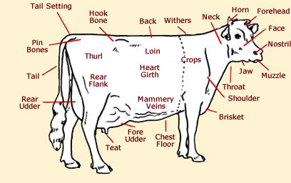

**EVALUATION**

1. State five breeds of cattle
2. List five importance of cattle

**CHARACTERISTICS OF CATTLE**

1. They are large bodied animals.
2. Most male and female cattle have horns some are polled.
3. They are either humped or humpless.
4. They calf at least once in a year.
5. They have a gestation period of about 275-283 days (9 $\frac{1}{2}$ months).
6. The female produces a calf in one parturition.

**SYSTEMS OF REARING CATTLE**

EXTENSIVE SYSTEM

This is the system in which the herdsmen move about with their cattle from one place to another in search of food and water. Movement is under the influence of rainfall, availability of pasture and Tse-tse fly. No organized housing and health care provided. The animals are exposed to natural hazards, thieves and wild animals attack and disease outbreak cannot be easily controlled. It is a very cheap system of rearing cattle and the animals enjoy feed of their choice and freedom of exercise.

SEMI-INTENSIVE SYSTEM

In this system, housing is provided and they are allowed to move about a fenced compound with pasture. They spend more time outside their pens. The system needs low capital investment but labour requirement is high. Diseases and parasites infestation are slightly high.

INTENSIVE SYSTEM

In this system, the cattle are confined within a building with little access to grazing. Grasses by zero-grazing, water and medication are supplied effectively to the cattle. Disease and parasite infestation is very low.

**EVALUATION**

1. Outline five characteristics of cattle.
2. What are the disadvantages of extensive system of rearing cattle?

**FEEDING**

1. The feed for cattle must be a balanced diet; they are grazers.
2. Cattle feed mainly on roughages (grasses and legumes). Common grasses that can be fed on by cattle include elephant grass, guinea grass and giant star grass etc.
3. Cattle should be fed on concentrate feed to supply the required nutrient in their diet.
4. Zero-grazing or rational grazing can be practiced.
   1. Zero grazing grasses are cut and taken to the cattle in their pens.
   2. Rational grazing-cattle are moved about in paddocks as they graze on the pasture.
5. Other feeds that can be fed to cattle include hay, silage, strawe.t.c.
6. Dairy cattle should be given more concentrate than the beef cattle

**MANAGEMENT OF CATTLE**

The management of cattle from breeding to market size can be grouped under three headings which includes

BREEDING TO CALVING (BIRTH)

Breeders are housed in the breeders’ house. The house is made up of railed wall and concrete

floors. Bulls and heifers should be at least 24 month before they are bred. The cow or heifers should be proper fed on concentrate as well as roughages. The bull is introduced to the cow when she is on heat. Gestation period is about 283 days. During gestation, the cow is made to eat in the ranch so as to exercise its body. Special diet is given to cows 8 weeks to calving for milk production after birth. This is called steaming up. The cow is taken to calving.

BIRTH OF CALF TO WEANING

During parturition, the cord from the navel breaks on its own. Iodine solution should be applied to the navel stump to prevent infection. The animal should be helped to suck milk from the mother’s udder. The first milk called colostrum is secreted by the mammary gland and it gives young animals natural immunity against diseases. Calf should be vaccinated against diseases and de-worm at intervals. Those not for breeding are castrated.

WEANING TO FINISHING

The weaned calf is fed with concentrate and roughages. The de-horning or dis-budding is performed for easy handling of the cattle when they grow up. De-horning can be done by using hot iron to burn out the horn bud or by applying caustic soda to the horn bud. Saw can also be used to cut off the horn and later treated with iodine. Branding and tattooing is later done for the purpose of identification of the calf. Ear notching can also be used for identification.

**COMMON PARASITE AND DISEASE OF CATTLE**

DISEASE OF CATTLE

1. MANGE is caused by mites

Symptoms include skin irritation, alopecia due to scratching to get rid of mites, thick and scaly skin.

It is transmitted by direct body contact. Treat all infected animals with insecticides and repeat after 2weeks, maintain proper hygiene and sanitation in pig houses, administer invermectin or ivomec injection.

Some effective insecticide again mange are diazuntol, malathione, benzyl benzoate, benzene hexachloride etc.

1. TUBERCULLOSIS is caused by bacteria

This disease is zoonotic, poor sanitation and hygiene are major factors that causes this disease.

It is transmitted via direct body contact, suckling infected milk, inhaling infected droplets from a coughing or sneezing animal with the disease, inhaling infected dust particles etc.

Symptoms include frequent dry coughing with whitish or yellowish discharge, swelling of lymph node on necks and front leg, hard lumpy and enlarged udder with pus filled/yellowish milk droplets, emaciation and death.

Can be treated by administering 10mg/kg body weight of isonicotinichydracide for eight

weeks but does not guarantee 100% recovery. It can be prevented by avoiding overcrowding, maintaining proper hygiene and sanitation, slaughtering of infected animals etc.

COMMON PARASITE OF CATTLE

Worms of cattle includes roundworm, flat worms, liver fluke etc.

Ectoparasites include tick, mites, tsetse fly, lice.

**GENERAL EVALUATION**

1. List five breeds of cattle
2. List five products that can be obtained from cattle
3. Outline five characteristics of cattle
4. Discuss briefly the intensive system of rearing cattle
5. discuss briefly the management of cattle from
   1. breeding to calving
   2. birth to weaning
6. List four other feeds that can be fed to cattle apart from fresh grasses.
7. Discuss briefly the common parasite and disease of cattle.

**READING ASSIGNMENT**

* Essential Agricultural Science for Senior Secondary Schools by O.A. Iwena chapter 32 page 318 – 323
* Answer the following questions from WAEC PAQ 1992 question 7, 2012 theory question 7, 2005 theory question 7 and 8, 2006 theory question 7, 2007 theory question 7 and 8

**WEEKEND ASSIGNMENT**

1. The gestation period in days of a cow is A. 283 B. 114 C. 42 D. 823
2. The discontinuation of feeding young animals with milk is known as A. lactation

B. weaning C.suckling D. feeding

1. Natural immunity against diseases is conferred on the newly born young animals through A. feeding of colostrumsB. vaccination C. Sanitation D. weaning
2. A young female cattle is referred to as a A. cow B. bull C. heifer D.vealer
3. The act of parturition in cow is known as A. kidding B. calving C. weaning D. sowing

**THEORY**

1. Define the following in cattle rearing a) tattooing b) zero-grazing c) rotational grazing.
2. Outline five economic importances of cattle.